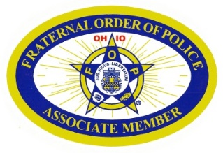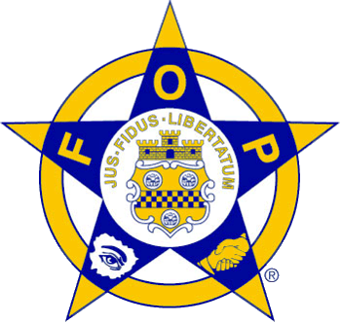

**Medina County Fraternal Order of Police Associates   
One family...working together!**

Do you believe in a better community, state and country?   
In protection for your family, home and business?   
In professional law enforcement?   
In a united effort to safeguard freedom and our way of life?   
If you answer yes, you are a candidate for membership in the F.O.P.A.

**What is the Fraternal Order of Police Associates (FOPA)?**The Fraternal Order of Police Associates is a civilian affiliate of the Fraternal Order of Police, with National, State and Local Lodges. Our members are responsible and respectable business leaders, professional people, family of Police Officers and citizens from all walks of life. Persons willing to give part of their time, money and energy towards helping law enforcement agencies or our Community, State and Country.   
  
The Associates is a citizens group that meet on a regular basis, pays moderate dues and serve at the pleasure of the parent Medina County F.O.P. Lodge 204.  
  
The Associates are a nonpartisan organization without bias toward race, creed, color or religious beliefs. We are an organization with local and state lodges throughout the country.   
  
The Associates objectives and interest revolves around law enforcement and men and women who have dedicated their lives to the protection of ours.   
  
The Associates are dedicated to supporting all law enforcement agencies in their legislative issues, charitable causes on local, state and levels.

**Goals of the FOPA**

The FOPA is an organization formed for the purpose of increasing our understanding of the rights, duties and problems of law enforcement officers; of fostering respect for them; and of bettering conditions under which they serve society. We accomplish this through public relations, as well as legislative and educational efforts. It is our aim and objective to support law enforcement throughout our country in every way possible. We believe that Law is the safeguard to freedom, and it is our duty to defend it.

**National History of the FOPA**

The Grand Lodge Fraternal Order of Police Associates was formed on August 27, 1967; organized on August 10, 1973; incorporated on March 21, 2005; and received its tax exempt ruling on April 13, 2006.  
  
Nationally, we are a proud corporate sponsor of Easter Seals, actively involved in legislation, and supportive of all Law Enforcement programs.

**Functions and Activities of the Associate Lodges of the FOPA**

Associate Lodges work to assist their parent Lodge. They provide law enforcement agencies with dedicated public support.  
  
Many Associate Lodges present scholarships to dependents of law enforcement officers and Associate members.  
  
Associate Lodges donate funds to officers in need or distress, provide funds for various law enforcement needs and youth programs, and present awards to recognize outstanding and dedicated law enforcement officers and Associate members.  
  
Associate Lodges hold joint social functions enjoyed by members, family, and friends.

**Benefits of the FOPA**

Membership in the Medina County FOPA entitles you to the following benefits:

* National fraternalism with our law enforcement family.
* Professional membership cards, decals, and emblems which are recognized nationally.
* Recognition of outstanding achievements through various awards programs.
* The opportunity to attend and vote at State and National FOPA Conferences.

**Do You Still Believe...**

...in a better State, Community, and Country?  
...in professional Law Enforcement?  
...in protection for your family, home and business?  
...in a united effort to safeguard freedom?  
  
If you answered YES, you are a candidate for membership in the FOPA!

**For information on membership email:  
FOPA99Secretary@gmail.com**